**RedCarpet Onboarding Guide for Nursing Students**

**Point of Contact for any questions or concerns:** [schoolsofnursing@seattlechildrens.org](mailto:schoolsofnursing@seattlechildrens.org)

**Due Date:** RedCarpet onboarding requirements must be complete at least 2 weeks before your start date. This allows time for your SCH username to be created, which then allows you to complete the rest of your required training prior to your first day of clinical or practicum.

# **Setting Up Your RedCarpet account**

Seattle Children’s will automatically send you a Welcome email with instructions for RedCarpet onboarding. If you do not receive this email, first check in your Spam/Junk folder, then email [schoolsofnursing@seattlechildrens.org](mailto:schoolsofnursing@seattlechildrens.org) to verify your email address and resend the Welcome email. This email contains your badge number (employee #) and a password.

Example:

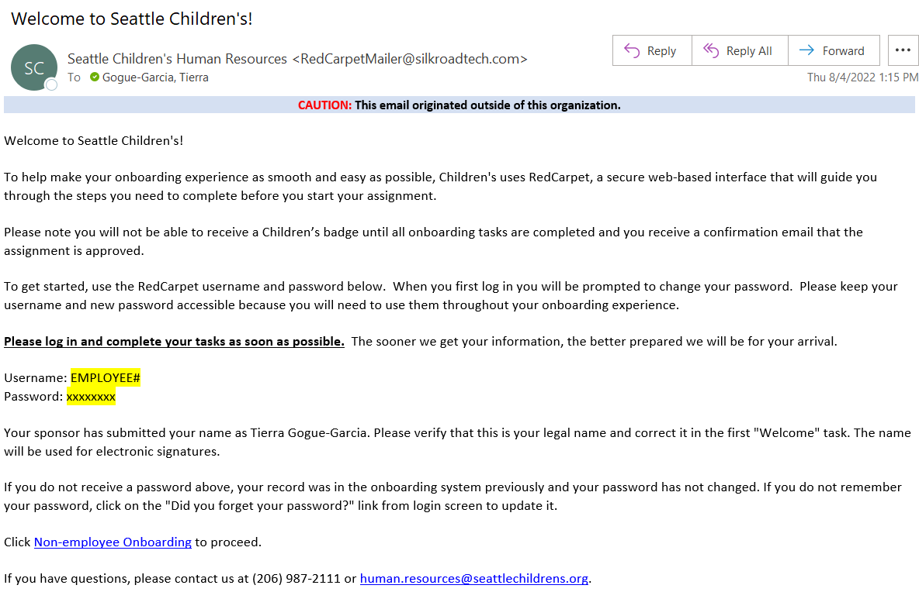

To begin, click on the **Non-Employee Onboarding link** which will direct you to the RedCarpet login page.

Sign in using your username (Employee #) and password provided in the Welcome email.

Example:

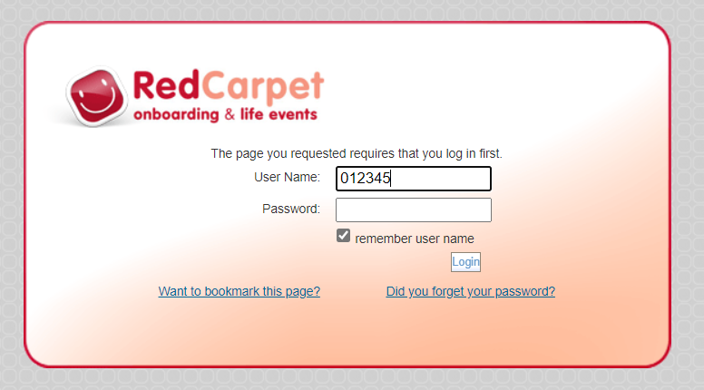

# **Completing Tasks on RedCarpet**

From the RedCarpet home page, you will find general information on the organization in “Home” as well as a **Task List** which contains your required onboarding tasks.

* Select the “Welcome” task to begin Onboarding and enter your general information.
* Once this initial task is complete, your remaining required tasks will appear. Complete all assigned tasks.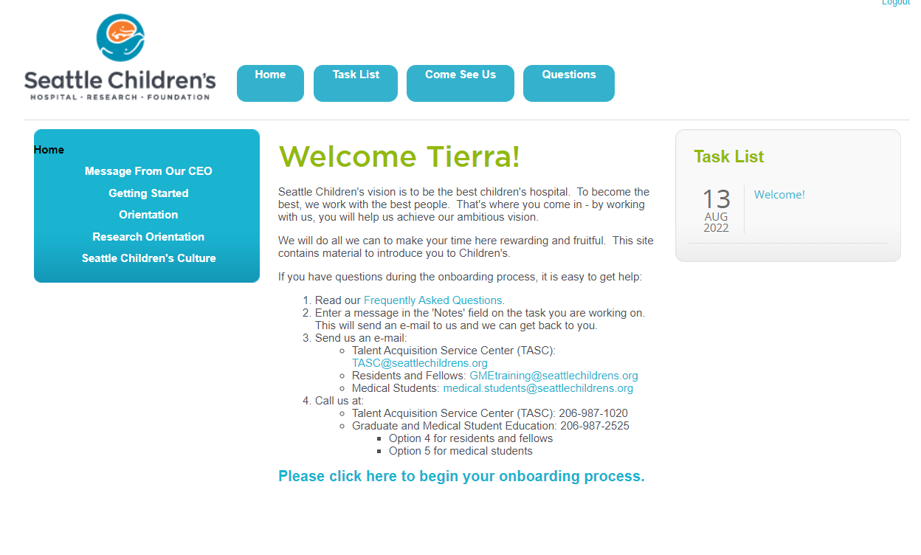

Note that RedCarpet may require up to 5 days to register your Task List as complete. Once your RedCarpet onboarding tasks are fully processed and marked as complete, you will receive the email notification with next steps:

Example:

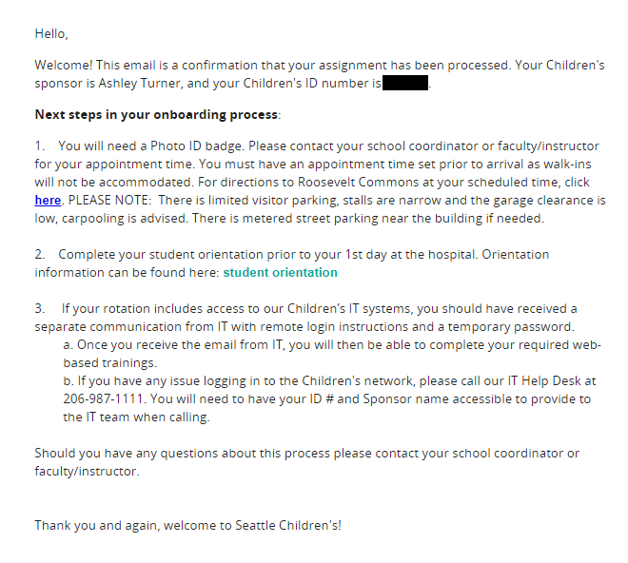

# **General Notes and Guidelines / FAQ for RedCarpet Onboarding:**

Remember that all RedCarpet onboarding requirements must be complete at least 2 weeks before your start date for your onboarding to process. Due dates mentioned in the email are automatic reminders and do not reflect 2 weeks before your start date. You will receive automatic emails like the example below:

Example:

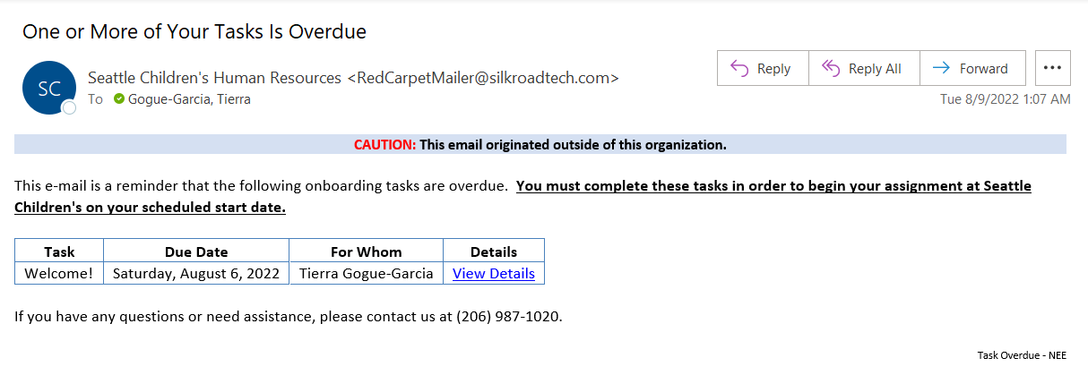

* Schools are responsible for providing student COVID -19 information. Faculty provide this information during their RedCarpet onboarding.
* If you do not have an SSN, enter 000-00-0000. HR is familiar with this scenario and will reach out to further assist once your RedCarpet is complete.
* Parking is free for students and faculty. You will be assigned a parking lot and will ride a shuttle to campus if you work day shift. (If you work weekends or are a senior practicum student on night shift, you will park on campus.)
* Your School Coordinator will work with our Talent Acquisition Service Center (TASC) team to schedule your badge appointment. You can disregard this step if prompted to do so.
* If you open a task and need to come back to it later, select “Save & Complete Later”. If you are ready to submit a task, select “Save & Complete Task”
* When signing agreements, make sure you select “Sign” and then “Save and complete Task” to complete the agreement. Your signature is case-sensitive and must be electronically signed the same name format as your profile.

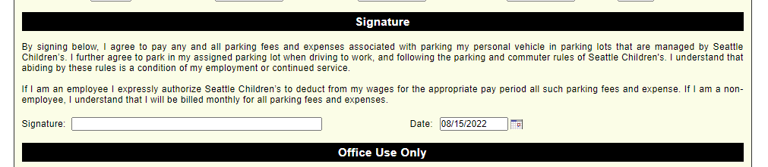

* The Non-Employee Orientation Presentation can be found on your Task List within the ‘Complete the required orientation’ task.

# **Receiving Your Username, Login, and Next Steps**

A week before your start date, you will receive your SCH username/user ID (which is different from your badge number/employee ID) and a temporary password in two separate emails. If you do not receive these one week before your start date, first check in your Spam/Junk folder for “caps-no-reply” then email [schoolsofnursing@seattlechildrens.org](mailto:schoolsofnursing@seattlechildrens.org)

User ID email:

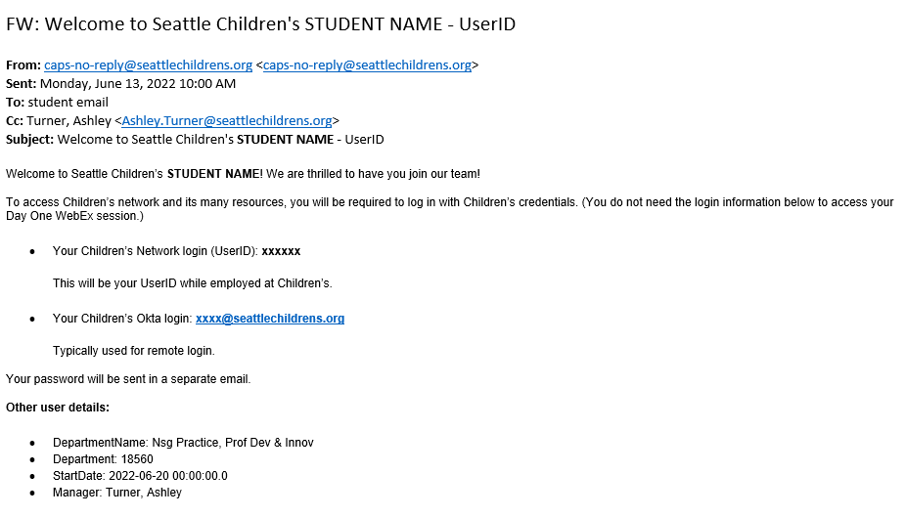

Password Email:

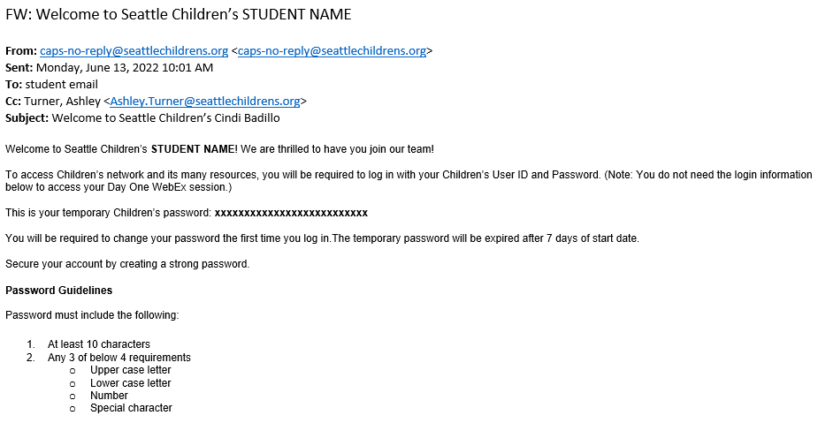

Once you have your username and temporary password, you will refer to Step 4 on the [Student Onboarding](https://www.seattlechildrens.org/careers/nursing/nppdi/student-onboarding/) page to complete your onboarding: <https://www.seattlechildrens.org/careers/nursing/nppdi/student-onboarding/>

*(Hint: Open the links below “Students will complete the requirements according to their role found in this document”)*