Seattle Children’s Training Site PALS/PEARS Course
Quality Assurance Checklist & Attestation
Training Site Name:
Training Site Lead Instructor:
Course: PALS Provider Date/Time: PALS Renewal Date/Time:
PEARS Date/Time: HeartCode PALS Part 2 Date/Time:

Teaching/Learning Environment | Yes | No | NA | Comments
Adequate space for content delivery & skills practice
Facility accessible to those with physical disabilities.
Functional AV equipment used for AHA curriculum
Adequate clean & functional PALS station equipment
Written exam is secured.
Course Content
HeartCode PALS Part 1 Certificates of Completion verified
Students have Provider Manuals for study & reference prior, during, and after the course
Students are given course outline/agenda for the day
Course Outline is consistent with AHA guidelines
Students are informed of criteria for successful completion.
Participant: Instructor ratio is < 8:1 for skills practice and
< 6:1 for Competency Testing
Cardiac Electric Skills equipment & practice is adequate
Vascular Access Skills equipment & practice is adequate
Respiratory Emergency Skills equipment & practice is adequate
Infant & Child BLS + BMV+ AED Skills equipment & practice is adequate
PALS Testing uses AHA competency test criteria for BLS skills, and Cardiac, Respiratory and Shock Core Cases
PEARS Testing uses AHA competency test criteria for BLS skills, and Respiratory and Circulatory Core Cases
Written Exam current edition is administered with adequate personal space; closed book, open mind.
Students review missed exam questions using Reference Key and Provider Manual to clarify rationale for answers.
Counselling is offered prior to retesting Written Exam B.
Counselling is offered prior to retesting Core Case Competency.
Course Evaluation: Submit student evaluation summary
Participants complete an anonymous course evaluation with opportunity to register compliments and complaints to an objective person of authority.
Attestation: As Course Director or Lead Instructor I verify these statements to be true.
Name: Signature: Date:
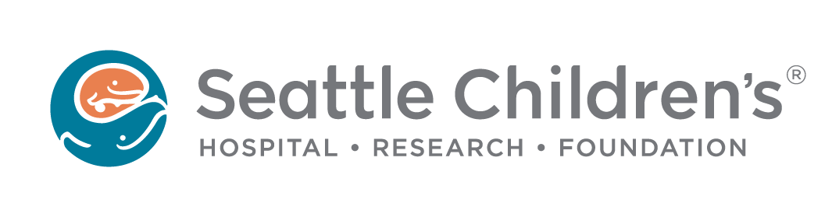
SCH TS PALS/PEARS Course Quality Assurance Checklist_Attestation_ 2016

