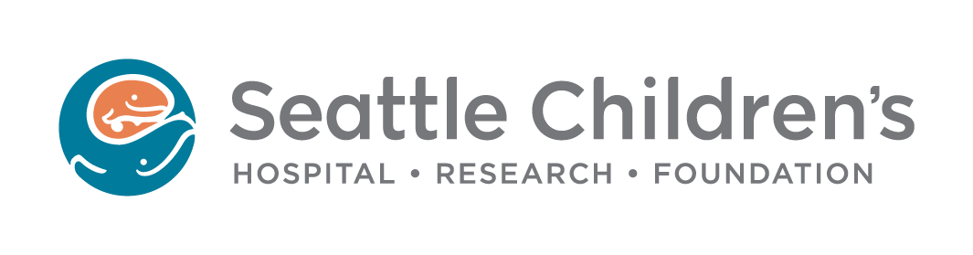

THIS DOCUMENT MUST BE WRITTEN IN YOUR LANGUAGE

SHORT FORM CONSENT
Consent to Participate in Research – Short Form

Introduction

At Seattle Children’s there are a number of research studies being done. The goal of research, in general, is to gain new knowledge. Children’s engages in research activities to foster new knowledge and to improve health care for children.

You are being asked to take part or allow your child to take part in a research study. Taking part in research is voluntary. We encourage you to take time to talk about the research study with family and friends.

Whether or not you or your child take part, you and your child will continue to receive the best of care at Children's Hospital. Your decision will not affect the care you or your child receive.

Before you decide if you want to take part in a research study, the researchers will give you information. The information will help you decide if you want to take part or allow your child to take part.

What do you need to know before you make a decision about taking part in research?

- WHY the research study is being done.

Before you make a decision the researchers will tell you why the research study is being done. They will explain what the researchers hope to learn from this study.

- WHAT will happen in the research.

The researchers will tell you:
- How long the study will last for you or your child.
- What will happen if you or your child take part.
- If any of the procedures or medications or tests are experimental.
- How the research study differs from the usual care you or your child would receive.

- What are your OPTIONS.

Some research studies, but not all, provide care and treatment. The researchers must tell you about all of your or your child's treatment and care options. You need to know what are your or your child’s care choices before you agree to be in a research study.

What are the RISKS of the research study.

The researchers will tell you:
- What are the risks to you or your child if you take part.
- How the risks of the research compare to the risks of standard care.
- Whether there may be risks that are not known at this time.
- What will happen if there is a research related injury and who will pay for treating the injury.

- What are the BENEFITS of the research study.

The researchers will explain if the research offers benefits to you or your child. They will tell you if the research might benefit future patients or society.

- You need to know about CONFIDENTIALITY

The information researchers learn about you or your child is confidential. The researchers will tell you who will receive information about you and others taking part. This information is called research data.

When a research study is testing experimental drugs or devices, two groups will receive the research data. One group is the U.S. Food and Drug Administration (FDA). The FDA is responsible for the safety of drugs and medical devices used in the U.S. The other group is the company making the experimental drug or device. The FDA and the company may review your or your child’s medical records to check the research data. All information about you or your child sent to the company or FDA is confidential.

- You need to know about COSTS

You will be told if there are additional costs to you from taking part in the research.

What if you don’t want to take part? What if you want to stop?

Taking part in research is voluntary. It is OK to say No. If you start, you or your child can stop taking part at any time. There is no penalty or loss of benefits for saying No or for stopping early.

Also, the researchers can take you or your child off the study. They will do so if it is in your or your child's best interest. If they stop the study, they will explain to you the reasons why.

What if you want to take part?

If you want to learn about the research study you will meet with a researcher. This researcher, with the help of a certified interpreter, will tell you about the study. You are encouraged to ask questions! If you want to take part, you will be asked to sign this form. You will be given a copy

of the signed form to keep. You will also be given a copy of the English consent form that describes this study. The researcher will sign the English form.

Important Telephone Numbers:
For questions about the research study, call the researchers at the telephone numbers on the first page of this form. Leave your name and telephone number and the researcher will return your call with an interpreter.

If you/your child have an emergency related to being in the research study, call 911.

Persons taking part in research have rights. (The last page of this form tells you about the rights of persons taking part in research). If you have questions about these rights, you may call the IRB at (206) 987-7804. The IRB is the committee that reviews and approves research at Children’s. The IRB is responsible for protecting the rights of children and families taking part in research. Leave your name and telephone number and a member of the IRB will return your call with an interpreter.

PLEASE NOTE: If you decide to participate in the research study, the researcher will have the English consent form translated to your language. The translated consent form will have all the details about the research study. The form will be given to you as soon as it is translated. This usually takes 1-2 weeks.

Participant/Parent/Legal Guardian’s Statement
I have been given an oral presentation of the research study. An interpreter fluent in my language has been present during the oral presentation. I have had the chance to ask questions. I understand that the persons listed on the first page of this form will answer any future questions I have about the study or about research participants’ rights. I know the number to call if there is an emergency. I voluntarily agree to take part or allow my child to take part in this research study.

PLEASE NOTE: If the participant to be involved in this research study is a foster child or a ward of the state please notify the researcher or their staff who is obtaining your consent.

______________________________________
Printed Name of Research Participant

_______________________________________________________________________
Signature of Research Participant (required if ≥ 14 yrs. of age)

___________ _____________

Date Time

_____________________________________________________________________
Printed Name of Parent or Legal Guardian

_____________________________________________________________________
Signature of Parent or Legal Guardian

___________ _____________

Date Time

_____________________________________________________________________
Printed Name of Parent or Legal Guardian

_____________________________________________________________________
Signature of Parent or Legal Guardian

___________ _____________

Date Time

Interpreter Information
PLEASE NOTE: Interpreter name is only recorded if consent is documented via a corresponding translated Short Form Consent and/or translated consent form.

_______________________________________________________________________

Name of Interpreter Date
(If interpreter is used during initial presentation of the study)

Witness Information
PLEASE NOTE: A witness name and signature is required when using the Short Form Consent to document consent/parental permission after the initial presentation of the study or as otherwise required by the IRB.

Witness Statement
I have been present during the oral presentation of this research study.

_______________________________________________________________________

Printed Name of Witness

_______________________________________________________________________
Signature of Witness

___________ _____________

Date Time

Copies to: Research Participant or Parent(s)/Legal Guardian

Medical Records (if appropriate)

Research Participant’s Rights*

Every person who is asked to be in a research study has rights. As a research participant, you or your child have the following rights:

1. To be told what the study is trying to learn,

2. To be told what will happen to you or your child during the study. To be told whether any of the procedures, drugs, or devices is different from what would be used in standard practice,

3. To be told about the frequent and important risks, side effects, or discomforts of the things that will happen to you or your child during the research study,

4. To be told if you or your child can expect any benefit from participating, and, if so, what the benefit might be,

5. To be told of the other choices for care you or your child have and how they may be better or worse than being in the study,

6. To be allowed to ask any questions concerning the study both before agreeing to be involved and during the course of the study,

7. To be told what sort of medical treatment is available if any complications arise,

8. To refuse to participate at all or to change your mind about participation or your child’s participation after the study is started. This decision will not affect your or your child’s right to receive the care you or your child would receive if not in the study,

9. To receive a copy of the signed and dated consent form,

10. To be free of pressure when considering whether you wish to agree to be in the study or agree for your child to be in the study.

*Adapted from the State of California Experimental Subject’s Bill of Rights

